C-FernTM Investigations:

Chemical Attraction
C-Fern Sperm Chemotaxis Kit

Student Version

Background
Chemotaxis is a widespread biological phenomenon that occurs in essentially every form of life, from single cells to multicellular organisms. Chemotaxis involves the ability by specific cell types to recognize the presence of a chemical gradient and to respond either positively or negatively to that gradient. Familiar examples of chemotaxis are the movement of bacteria toward or away from a particular chemical (e.g., foodsource) and the nearly universal ability for single-celled gametes to locate one another in order to accomplish fertilization. Chemotaxis is even considered to play a key role in the metastatic behavior of certain types of malignant cancer cells as they spread to different tissues in the body.
Chemotaxis can be easily demonstrated in cultures of C-Fern gametophytes by observing the natural sequence of fertilization events that occur upon adding water to cultures. Mature (12+ day-old) populations of C-Fern gametophytes contain two distinct sexual types, small thumb-shaped males and larger heart-shaped hermaphrodites. While the males contain only antheridia (male sex organs), hermaphrodites contain both antheridia and archegonia (female sex organs). Antheridia are composed of a few outer cells that enclose 16 sperm at maturity. Archegonia consist of a short neck that protrudes from the surface of the gametophyte directly behind the actively growing meristem region located in the notch of the heart. An egg is located at the base of each archegonial neck. By adding water to a mature culture, it is possible to observe the release of thousands of swimming sperm (mostly from males). The sperm are positively attracted to receptive archegonia. How do sperm know where the archegonia (and eggs) are? Sperm are attracted to chemical substances (positive chemotaxis) that are contained in a small drop of liquid that is discharged from the necks of receptive archegonia. One sperm eventually succeeds in fertilizing each egg.
In addition to observing these natural behaviors in culture, it is also possible to artificially manipulate sperm so that experiments combining aspects of both chemistry and reproductive biology can be conducted. In this exercise you will use a simple technique to obtain a suspension of sperm and then test the ability of the sperm to respond to several test substances.

Learning Objectives
- Observe natural and artificially manipulated chemotaxis in C-Fern sperm
- Learn techniques of qualitatively interpreting experimental results.
- Gain experience with viewing and manipulating objects under the microscope
- Learn about the structural differences between chemical isomers and how the differences can effect their biological activity

Procedures and Observations
Your instructor will provide you with 12-18 day-old cultures of C-Fern gametophytes. These cultures should be maintained under the standard culture conditions until just before use. Do not remove cultures from under the lights or from the Culture Domes until steps 1-3 have been completed!

1. Using the razor blade, carefully sharpen six of the wooden toothpicks provided (for each group, up to six groups) so that one of the ends has a very fine point. Use the razor blade carefully! Cut away from yourself and watch your fingers. When you are finished sharpening, do not touch the sharpened end with your fingers. Carefully lay the toothpicks down on a clean surface. Replace the razor blade in the container designated by your teacher.

2. Use the pen to make from 1 to 5 small dots along the side of the toothpicks near the unsharpened ends, so that each toothpick has a unique marking (i.e.,1,2,3,4,5) and one is kept unmarked. Take the toothpick with one dot and dip the sharpened end of it into the vial containing test solution #1. Place it, sharp end up, in the toothpick holder (foam block). Repeat with the remaining 4 test solutions, leaving the final unmarked toothpick dry.

Q1. Which of the toothpicks will serve as a control? Why is the one you chose appropriate to be used as the control?
3. Obtain a concavity slide and, using the pipette, place one drop of the Sperm Release Buffer (SRB) in the central depression.

4. Now obtain a petri dish containing mature C-Fern gametophytes. Open the dish and observe it under a stereomicroscope using transmitted (bottom) illumination. Note the two types of gametophytes that are present, larger heart-shaped hermaphrodites and smaller thumb-shaped males that have many bumps on them (Fig. 1). Take the dissecting needle and carefully pick up males only and transfer them to the drop in the concavity slide. Be careful to not damage or wound the gametophytes during transfer. If one is wounded, discard it. Transfer a total of 7 – 10 male gametophytes to the drop. It is not necessary to submerge them completely, only to place them within the drop of buffer.
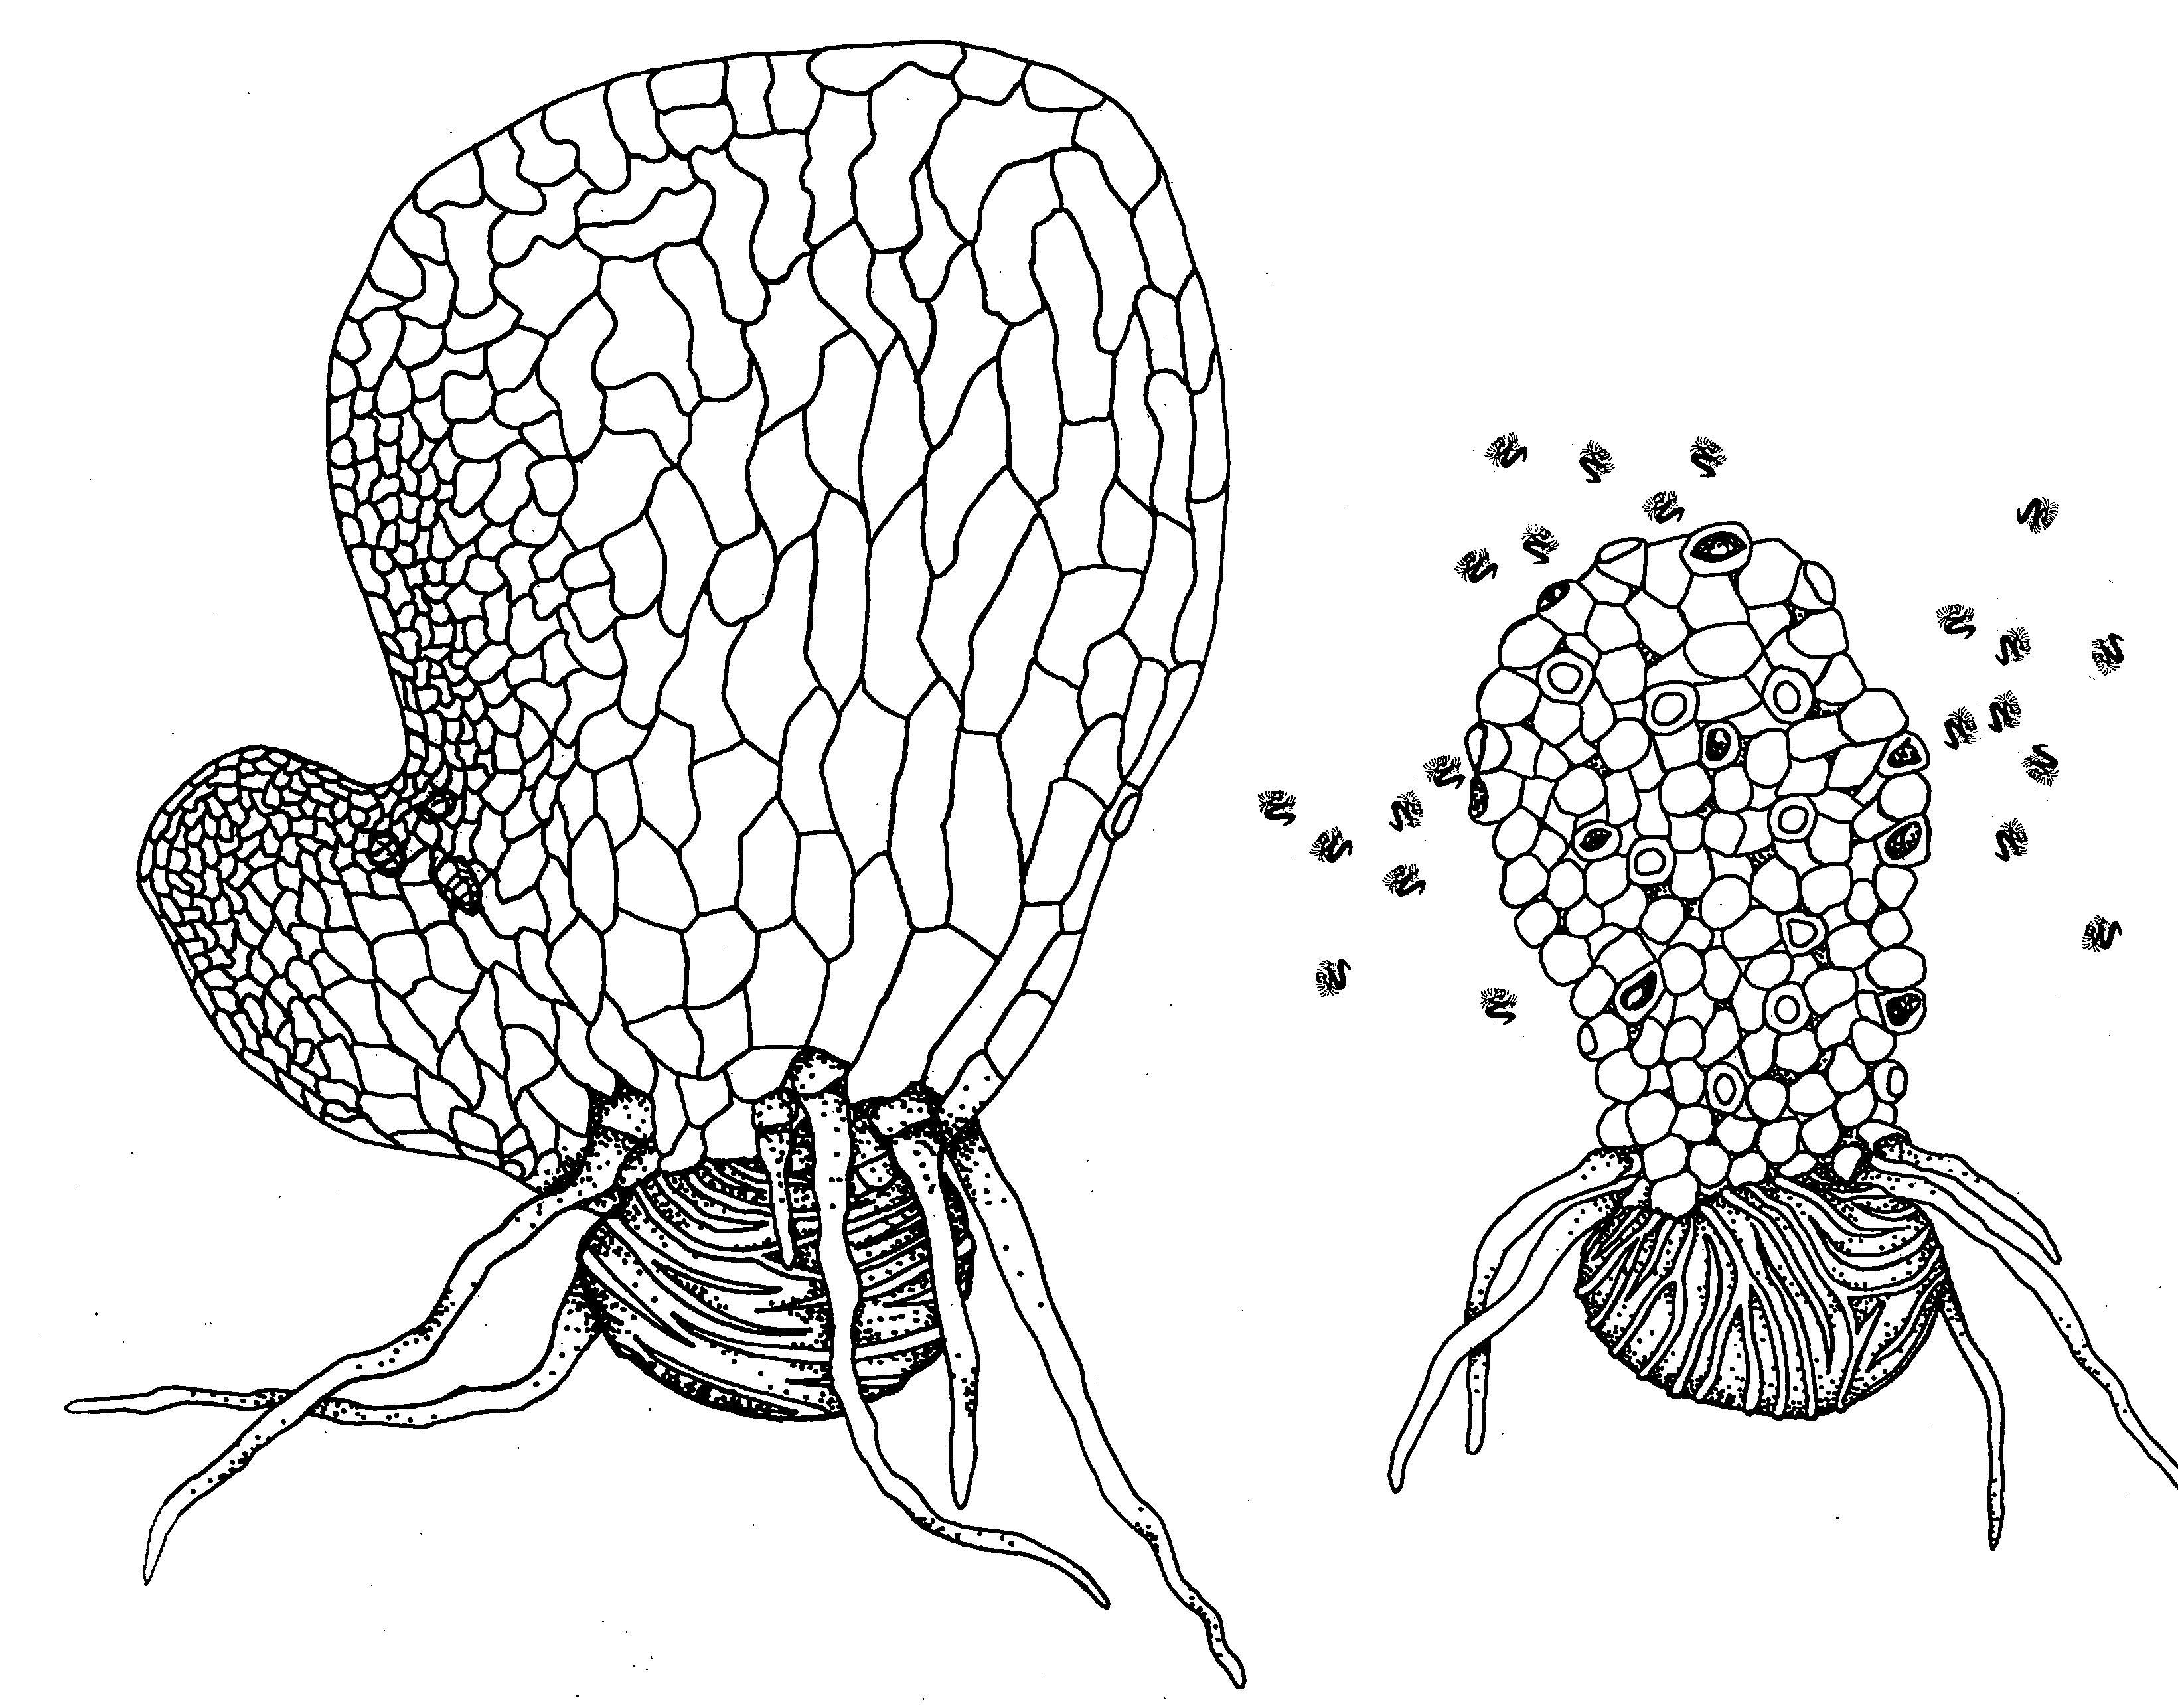
Figure 1. Mature (12-day-old) hermaphrodite (left) and male (right) C-Fern gametophytes.

Q2. Why are only males transferred to the drop of buffer?

5. Place the slide on either the lid or bottom of an empty petri dish, edges up, and observe it under the stereoscope under low magnification (12X or higher). The use of the petri dish will keep the slide and sperm suspension cooler and provide a clearer view. In a few minutes, usually less than five, sperm should begin to be released from antheridia. Adjust the illumination on the stereoscope to provide the best contrast for viewing the sperm. Your teacher will assist you.

6. After a large number of sperm are released (about 3-5 min), begin testing the response to the test solutions as follows:
- Using 12-20X magnification, carefully focus on the TOP surface of the drop of sperm suspension, in an area free of male gametophytes.
- Take a test toothpick and, while looking through the microscope, gently and briefly touch the sharpened end of the toothpick to the surface of the drop. Do not stick the toothpick fully into the drop – only touch the surface briefly. See Figure 2a.
- Observe what happens, if anything, during the next minute and record your observations in Table 1.
- After you have made your observations, repeat the procedure with the remaining toothpicks. If necessary, use the dissecting needle to stir the sperm suspension and re-distribute sperm after each of the tests. This is typically needed only after a strong chemotactic response is observed.

METHODS HINT: If you wish to repeat any of the tests, simply re-use the toothpicks. Stir the suspension as needed to distribute the sperm randomly. It is also possible to test two substances simultaneously by holding two toothpicks together (side-by-side) so that their sharpened tips line up. Then, while observing the sperm suspension, briefly touch the tips to the drop of suspension as before (see Fig. 2b). Observe the two points of contact and compare the responses directly.

- OPTION: Wound one of the gametophytes in the sperm suspension by puncturing it with the dissecting needle. Observe what happens. Another option is to crush a gametophyte from the original culture dish with a sharpened toothpick and test this toothpick as described above. Record your results.
- OPTION: Your teacher may provide you with toothpicks that contain the natural chemoattractant from the exudate from archegonia. Alternatively, you may prepare these in laboratory following instructions from your teacher. Test these as above and record your results.

Figure 2a. Proper technique is important. Gently and briefly touch the end of the toothpick to the surface of the sperm suspension. Note: The size of the drop of suspension is exaggerated to show detail.
Figure 2b. Simultaneous testing with two toothpicks held side-by-side.

Q3. You may have observed a very weak response by the sperm to the control toothpick. How could this be explained and does it invalidate the experiment?

Q4. Which of the test chemicals caused the strongest response?

Q5. Examine the chemical structures provided by your teacher. Can you relate the biological response differences you observed (chemotaxis) to any chemical structural differences between the test substances?

Q6. Can you relate the positive chemotactic activity of some of the chemicals to the natural attraction of sperm to substances in the exudate from the necks of receptive archegonia?

Q7. If you tested the chemoattractant effect of wounded gametophytes (step 6e.), can you relate your observations to the natural attractant discussed in Q6?

Table 1. Chemotactic response of C-Fern sperm to test substances.
Test Substance | Swarming Response¹
Test Substance | Intensity (low, medium, high) | Duration (short, medium, long) | Comments
¹A quantitative measure can be approximated by assigning values (0,1,2,3…) or symbols (-,+, ++,+++…) to the responses. This allows easier comparison with data sets generated by other students.

Figure 3. Chemical Structures of the Test Compounds.

D

A

B

C

E

